BHG Daily Exports Tasks

Credentials for 222 machine should work
Check scheduled jobs after 4-5pm
- Executables
  - Located on 10.50.5.223 @ C:\users\bcatellier\Documents\BCApps
  - Source Code: 10.50.5.223 @ C:[users\bcatellier\Documents\BCAppCode
  - Visual Studios Project file : C:\Users\bcatellier\Documents\BCAppCode\BHG\BHG.sln
  - There are several schedule jobs which are managed by the windows task scheduler: 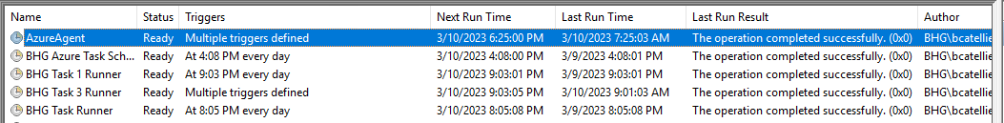
  - TaskRunner takes an argument of 1, 2, 3 where 1 is Global, 2 ETL tasks and 3 any other tasks.
    - 1 = SAMMSGlobal
    - 2 = Central ETL P1, Eastern ETL P1, Mountain ETL P1, Pacific ETL P1
    - 3 = any others (disabled in Task Scheduler)
    - 4 = Central ETL P2, Eastern ETL P2, Mountain ETL P2, Pacific ETL P2
    - 5 = Samms-LAB
    - 6 = Samms-Forms
    - 7 = SAMMS-ETL-Notes
    - 8 = SAMMS-ETL-INV
    - 9 = SAMMS-ETL-DartSvc
    - 10 = SAMMS-ETL-Dose
    - 11 = SAMMS-ETL-Orders

- Checking to scheduled tasks for the daily ETL.
  - select * from tsk.ParentTaskView
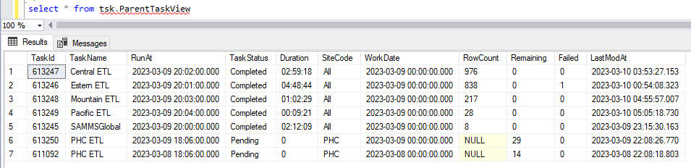
  - Select * from tsk.vwTaskList
where RowState = 24 and Status <> 19 and RunAt >= GetDate()-2
order by ParentTaskId, WorkDate, TaskName, SiteCode

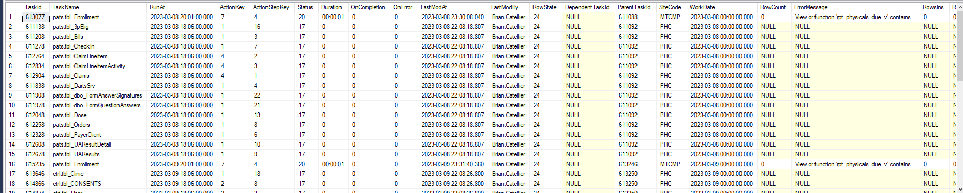
- Reviewing Errors with ETL
  - Any rows with status equal to 20 indicates an error.
  - The field ErrorMessage will hold the error message from the ETL process.
  - Errors range from Network time outs to views with self-references. “View or function 'rpt_physicals_due_v' contains a self-reference. Views or functions cannot reference themselves directly or indirectly.”
  - Rows with Errors can be re-scheduled by resetting the status to 17 and setting the Parent task’s status to 17 as well.
    - declare @wrkDt date = '3/15/2026';
update tsk.tbl_Tasks2 set Status = 17 where TaskId in (select ParentTaskId from tsk.tbl_Tasks2 where WorkDate = @wrkDt and Status = 20);
update tsk.tbl_Tasks2 set status = 17 where WorkDate = @wrkDt and status = 20;

- If a scheduled Parent Task fails to run or does not finish; The scheduling process will remove tasks which have a where condition of 1 = 1 (full table loads) and reset the status field to 17, when submitting the new tasks.

- To create a Task and sub-task: You would insert a parent task, setting a Name and Run Date time. As a parent task does not have a parent, leave the parenttaskId set to null. For the sub-tasks, you will add the tasks naming them with schema and table name as the task name. All sub-tasks should have the parent task id set the task id of the parent task. The easiest way to do this is to select from this table the rows in which you will want to run as the new tasks, updating the data for the parent task and runat date time. The following insert statement can be done be value or sub-select;

  - insert into tsk.tbl_Tasks2 (TaskName, RunAt, ActionKey, ActionStepKey, Status, RowState, LastModAt, LastModBy, SiteCode, WorkDate, Duration, onCompletion, onError)
  - --values ('PHC ETL', '2/5/2022 16:04:00', 0, 0, 17, 24, GetDate(), 'Brian.Catellier', 'ALL', '2/5/2022', '0', 0, 0)
  - select Name, NextRunTime, ActionKey, 0, 17, 24, GetDate(), 'Brian.Catellier', Case when scheduleid = 18 then 'PHC' else 'All' end, Convert(date, NextRunTime), '0', 0, 0 from tsk.tbl_Schedule where Enabled = 1

- Adding a new table to the ETL process;
  - Create the table in Azure.
  - Create a class for table structure in BHG_DR_LIB Models.
  - Create a save method for the new table in the BHG_DR_LIB.
  - Add a case to the switch statement in the TaskRunner program to call the save method.
  - Create a new MapAction row to process the new table in Azure dms.tbl_MapAction and create the structure in dms.tbl_MapSrc2Dsn, enabling the fields you want brought into azure.
  - Recompile the executable and test. After testing, copy the executable and other files to the C:\users\bcatellier\documents\bcapps\...

- Removing a table from the ETL process;
  - Disable the task from dms.tbl_MapAction
  - To remove this table completely, the items created above can be deleted and recompile and copy to run location.

- Modifying an existing table,
  - Add or remove the column from azure table.
  - Update the model in BHG_DR_LIB
  - Update Save method.
  - Update dms.tbl_MapSrc2Dsn, enable or disabling field.
  - Recompile, test, and publish executable files.

Control Tables for ETL Process;

Ctrl.tbl_Locations SiteCodes and Clinic Names
Ctrl.tbl_LocationCons Maps Sites to DatabaseNames to ActionKeys
Dms.tbl_MapActions Maps Tables to ActionKeys
Dms.tbl_MapSrc2Dsn Maps Columns to Tables
Ctrl.tbl_Forms2Process Maps Forms to Tables and Identifies Signature fields
Tsk.tbl_tasks2 Log of tasks processes
T.tbl_schedule Maps ETL Processes to Tasks

Forms ETL
Loops Sites (Tasks)
Loops (tbl_Forms2Process)
Biulds Select union together each different form
Gets Data
Uploads into Azure (SaveData methods)

All Other Tasks (Tables)
Loops Tasks (Sites and Tables)
Based on Task Name switches to table
Gets Data based on Select from enabled fields in dms.tbl_MapSrc2Dsn
Save Data based on Task Name
Creates an object of destination table and populates by looping columns or does a bulk upload to stg scheme and calls a stored procedure to merge data.

